CS-7641-001 MC2-Project2 (Extra Credit)

gatech ID : nghosh9

1. What do you think of refining and testing your strategy over the same 2 years? Is that a good practice? Why or why not?

I would not be supportive of refining (training) and testing my strategy over the same time period. There is a big chance that it might lead to the strategy over fitting the data in this time period as we continue to tune our parameters. This would mean that although the strategy might really perform well in this duration it will lead or suboptimal or even negative results in other time periods. Hence we should be careful to not make our strategy biased to a particular test data set.

1. Test your strategy in years before and after 2008-2009. Does the strategy continue to work well in those time periods?
2. **Period 2006-2007 – Summary – Results were not up to mark**

**Returns : 2.5%**

Performance

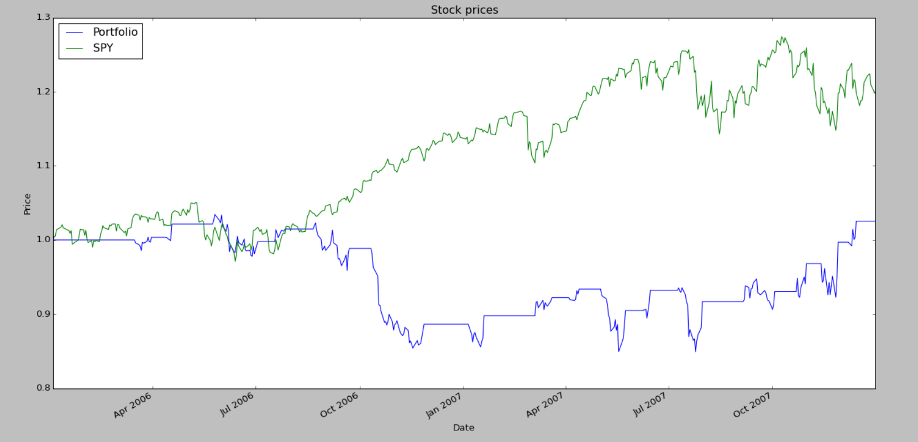

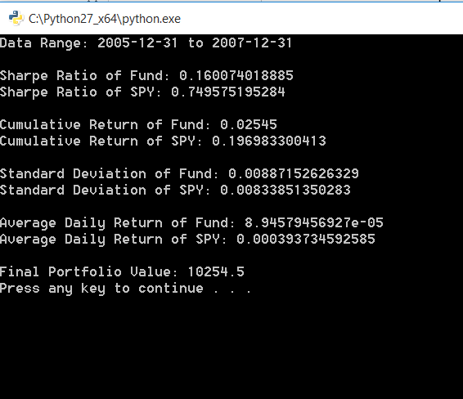

As you see, my strategy did not do well with a net portfolio worth 10,254 at the end of the period.

Now, this result led me to think about why this strategy of being over aggressive did not work in this case (later it occurred that that the general Bollinger band strategy would not work towards best results in this time periods – really an eye opener).

Why so?

Now the way Bollinger bands work, I initially had an illusion that it would be profitable always (almost). Here are my observations, as to why it did not work.

1. In this case, the stock values don’t move too far away from the SMA most of the time – i.e the standard deviation of the stock is within the Bollinger bands most of the time. This means that you don’t get too many exit signals from your stock. Just alone this should not too much of a problem as long as the momentum of the stock continues in a favourable direction – but you can’t guarantee that, can you?
2. Now with the above point in mind look at the highlighted region of the signal indicator graph below.

* red line : short entry
* orange line : aggressive short entry
* green line : long entry
* brown line : aggressive long entry

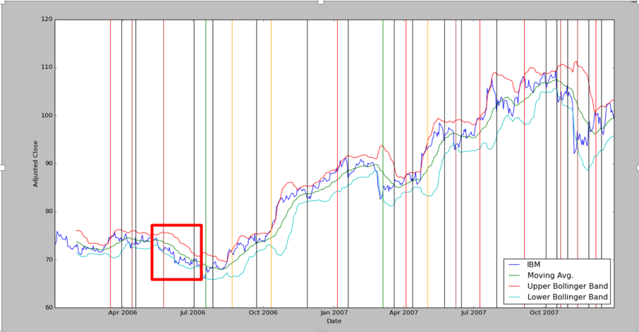

After having made an **aggressive long entry (this was in combination to looking at the market movement)** you see that the net momentum of the stock is downwards. Yet there was no significant deviation of the stock from the SMA so that it could give an exit signal. Multiple such scenarios proved disastrous for this strategy and it ended up making minimal profit, although it could have easily catapulted into losses.

1. **Period 2010-2011 – Summary – Results were good but had similar glimpses of the problem described above**

**Returns : 23.5%**

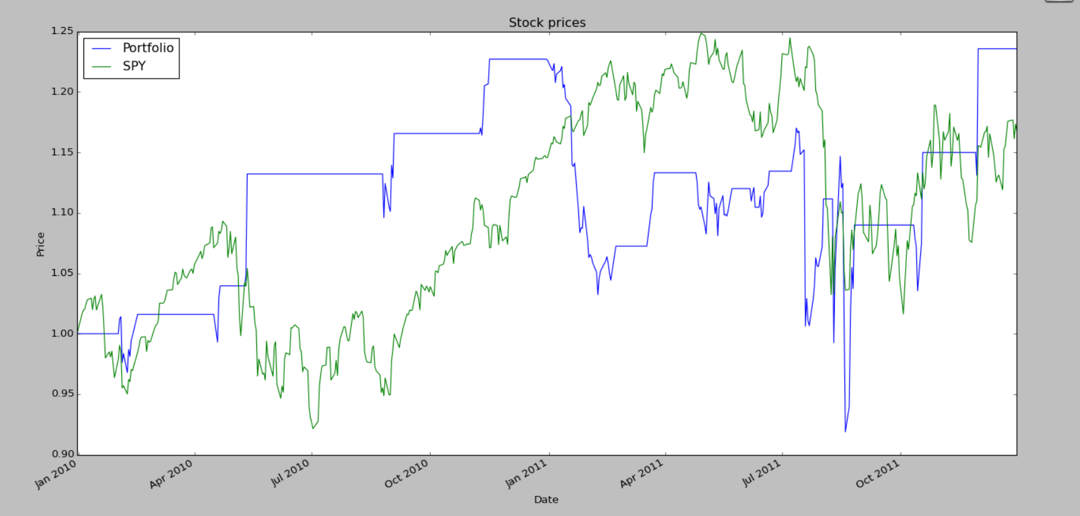

**Metrics:**

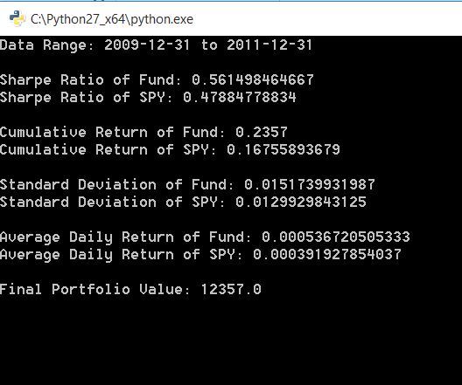

The results in the time period 2010-2011 were pretty good. But I will not be driven into the false illusion of believing that the strategy is good. The returns were good as there was greater volatility and greater exit signals at the right time (the momentum favoured the entry/exit signal times).

An example where an opposite scenario to the ill timed long signal in the previous period is shown below. Here after throwing a short signal the stock price just did not fall so that it would cross the SMA. Much later when the stock had already risen a lot it gave an exit signal. This resulted to a huge loss if you look at the portfolio graph above. Simlar excursions happened at the later stage of the year 2011 which led to a massive fall in the portfolio value.

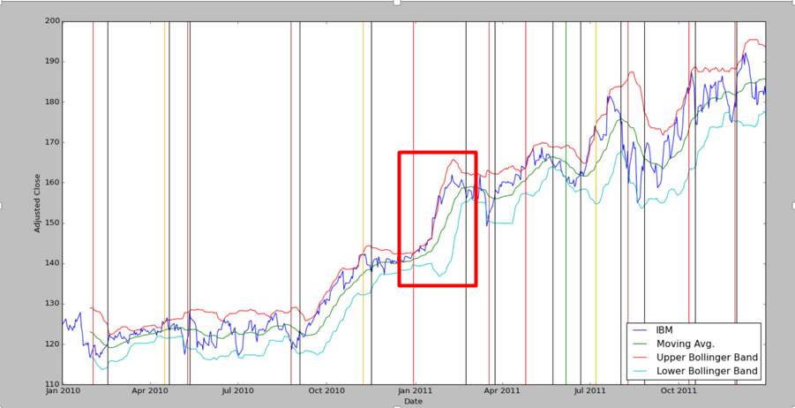

1. **Summary**

In all I learned that Bollinger bands as an indicator just by itself would not always prove optimal results and you would want to combine multiple indicators along with other strategies to get better results

Thoughts about improving the strategy

* Use tighter Bollinger bands (less than 2 STD above and below the SMA) depending upon the current volatility the stock is displaying
* Use a momentum indicator alongwith Bollinger bands to give more decisive entry/exit signals.